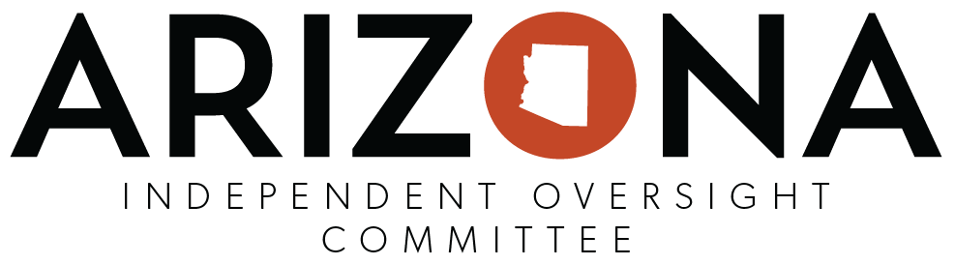
IOC Formal Objections to Specific Problems or Client Rights Violation/s
Instructions: To expedite the process, this optional template can be used upon the majority vote of a quorum of IOC members to submit a formal objection to “specific problems or client rights violation by department employees or service providers” to an Agency Director (A.R.S. §41-3804.F & A.R.S. §38-431). The IOC Chairperson should ensure completion of the form, then sign, date, and submit to the appropriate agency via email and send a copy to ADOA at ioc@AZ.gov.
NOTE: The information contained within this document is confidential and shall be sent directly to the Agency Director according to A.R.S. §41-3804(F)

IOC Name: ________________________________________________________________________________________
IOC Chairperson/Designee Submitting Form:___________________________________________________________
IOC Meeting Date: _________________________________________________________________________________
(actual meeting date that the formal motion made/approved by a majority vote of IOC Members to submit the formal objection)

Name of Agency involved:
Name of Client/s involved:
Name of Service Provider involved: (if applicable)
Name/s of department or provider employee/s involved:
Detailed description of the objection, problem and/or specific client rights violated:
Known date/s and/or time/s of occurrence/s:
Supporting evidence: (summarize and attach any related documentation/ information if needed)
Other specific/relevant information:
Recommended relief/resolution: (if applicable)

Signature: _____________________________________________ Date Submitted: ____________________________

