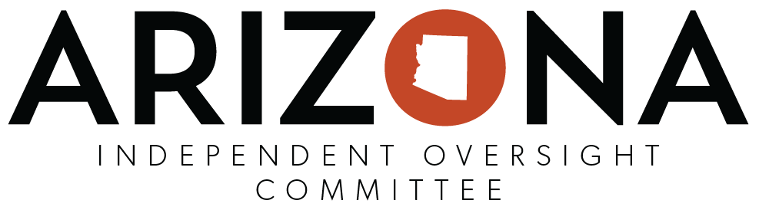
IOC Formal Recommendation
Instructions: To expedite the process, this optional template can be used upon the majority vote of a quorum of IOC members to submit formal recommendations to an Agency Director regarding laws, rules, policies, procedures and practices to ensure the protection of the rights of members receiving behavioral health and developmental disability services (A.R.S. § 41-3804.3 & A.R.S. §38-431). The IOC Chairperson/should complete the form below in detail, then sign, date, and submit to the appropriate agency via email and send a copy to ADOA at ioc@AZ.gov.
Note: To ensure confidentiality & compliance of ARS §36-509 do not include any confidential information (PII or PHI)

IOC Name: ________________________________________________________________________________________
IOC Chairperson/Designee Submitting Form:___________________________________________________________
IOC Meeting Date: _________________________________________________________________________________
(indicate the actual meeting date that the formal motion made/approved by a majority vote of IOC Members)

Name of Agency involved:
Name of Division involved:
Specific laws, rules, policies, procedures or practices involved: (please list all)
Detailed description for the reason/s of the recommendation/s:
Supporting evidence: (summarize and attach any related documentation/ information if needed)
Other relevant information:
Specific recommended change/s:

Signature: _________________________________________ Date Submitted: ________________________________

PII: Personally Idenfieable Information / PHI: Protected Health Information

