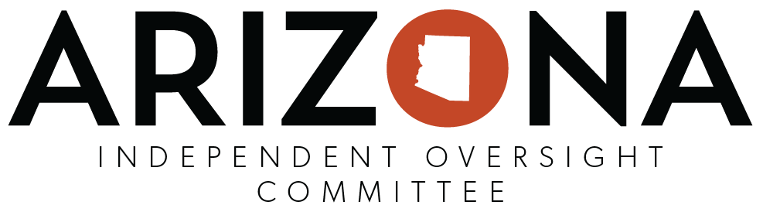
NAIOC FACILITIES AND SERVICES VISITATION CHECKLIST
Facility or Service Name: _______________________________________________________
Address: ____________________________________________________________________
Phone: _________________________________ Visit Date: _________________________
Name of Agency/Organization Director/Representative: _______________________________
Names of NAIOC Reviewers: ____________________________________________________
Licensed: □ Yes □ No License # (if applicable): ________________________________
Name of RBHA/Provider: _______________________________________________________
# of Beds: __________ Monthly Rent $: ___________
# of Current Residents: ______ # of Male Residents: ______ # of Female Residents: _______
Visual Observation–Describe facility

Information Obtained from Agency/Organization Director/Representative:
How do residents find out about your facility?
How are meals provided?
Describe contact with residents’ case managers and/or providers.

Questions - What is the process you use to dispense medication?
Do you store resident’s medications?
Do you remind residents to take medications?
Do you read the medication label to the resident to ensure that resident patient is taking it correctly and/or to reassure resident that they are taking correct dosage?
Do you open the medication for the resident?
Do you distribute/pour out medications for residents?
Do you observe resident to make sure meds are taken?
Other Questions
What is the facility policy for keys? Do you have a key?
Is unit furnished or unfurnished?
What is your process for pest control (does this include specifics for bed bug prevention/treatment)?

What time are meals served?

Are clients allowed seconds?
What is your policy for snacks? Accessible? Storage? Limits? Sanitary?
What is your procedure for evacuation? Posted? Practice?
Are there fire and smoke alarms and are they in working condition? Sprinklers?
What kind of information is maintained for clients’ emergency contacts?
What kind of Staff do you have on a shift and what is their training? What training do you provide? Credentials?
Are electronic devices permitted, used such as cell phones, ipads, etc.? What is your policy for use of wireless or electronic devices on shift?
Are emergency phone numbers posted?

Are clients’ rights posted?
Is there a curfew?
What kind of laundry facilities do you have?
What instances invoke disciplinary procedures for residents? Staff?
What activities are provided for the clients? Describe:
Information Obtained from Residents - Did resident express satisfaction concerning the following?
Meal
Feeling safe
Rules of facility
Money management
Treatment by staff
Treatment by other residents

Living conditions (adequate bedding, hot water temperature, etc.)
His/her daily activities
Access to money
Access to transportation
Privacy
General enjoyment of life
How could the site be improved?
Access to adaptive devices? Are they appropriate?
Contact with case manager?
Are you familiar with your current ISP or treatment plan?
Do you store your own medications?
Are you reminded to take medications?
Are medication labels read to you?
Do you pour your own medication?
Do the staff watch you take your medications?

Are medications kept in locked places (rooms/boxes)?
Does staff have a key to your unit?
Do you have a key to your unit?
Concerns of Reviewer(s) - Did reviewer find evidence that conflicted with person’s statement?

Identification of Abuse Yes / No (residents hurting each other; harmed by staff; inappropriate grouping of people)
Staffing Issues Yes / No (respectful treatment by staff; residents treated as individuals)
Identification of boarding home safety and/or living issues Yes / No (close to bus; “hominess”, safety hazards on property; cleanliness)
Evidence of substantial medication problems Yes / No
What is the condition of the furniture?
Are the units clean and maintained?
Food storage/spoilage problems, most recent health inspections? Yes / No
Any violations of Individual’s rights?

